SMT Music Session 1: Grades TK-2

Apples!

Part 2 of 3

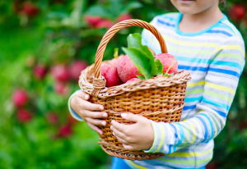

*The activity/activities are due via upload on Seesaw by Monday, September 21.*

Daily Greeting: Hello Song

Sing our opening song and be sure to say hello to each of your classmates right after me!

Grade TK: <https://youtu.be/MOZW_Gc75-8>

Grade K: <https://youtu.be/09zylsoEN74>

Grade 1: <https://youtu.be/bGpo99gk2Yc>

Grade 2: <https://youtu.be/jLO_mvfcAWA>

Sing this song with me! <https://youtu.be/RH9fZKa6D3k>

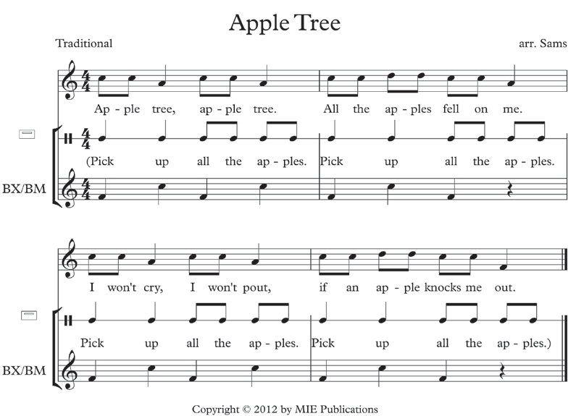

Let’s look more closely at our music. The song *melody* is on the top, right above the “apple tree” words, or *lyrics.* It has two *rhythm* patterns. Rhythm in music is the way patterns fit into the *beat*,which is a steady pulse, like a heartbeat, that we can feel. It keeps the music together.

In the *Apple Tree* song we have one rhythm pattern with two quick (short) notes, and another pattern with one slow (long) note.

The quick notes are connected with a line called a *beam*. ♫ They are called *eighth* notes.

The slow note has only a stem. ♩ It is called a *quarter* note.

So, the rhythm of our song goes like this:

Ap - ple tree Ap - ple tree. All the ap - ples fell on me.

short-short long short-short long short-short short-short short-short long

♫ ♩ ♫ ♩ ♫ ♫ ♫ ♩

I won’t cry, I won’t pout, if an ap - ple knocks me out.

short-short long short-short long short-short short-short short-short long

♫ ♩ ♫ ♩ ♫ ♫ ♫ ♩

Did you notice that both lines of lyrics have exactly the same rhythm? We can clap the rhythm of the song, and then we can also say or sing the song keeping a steady four-beat with our claps or taps. Try it with me! <https://youtu.be/ChPSZAK-xbI>

Here is another way we can put our two rhythm patterns together. Pretend that you are in a beautiful apple orchard and the sun is shining with a blue sky overhead. We see that some apples fell off the tree and are lying on the ground. Let’s gather up the fallen apples! Make an “apron” with your shirt or put all your “apples” in a small basket. As we do, we are going to chant our *ostinato*. *Ostinato* is pronounced: “aw-stih-naw-toe,” and it means to repeat a musical phrase or rhythm over and over again. This word is an important musical term in Italian. Most musical terms are in Italian, as many of you already know. This is because Italy was the place where music was first written down. *Ostinato* is pronounced: “aw-stih-naw-toe,” and it means to repeat a musical phrase or rhythm over and over again. Our *ostinato* for today will be taken from the middle line of the sheet music above:

Pick up all the apples! Pick up all the apples!

♩ ♩ ♫ ♫ ♩ ♩ ♫ ♫

We can chant our ostinato in rhythm as we mime, or, act out, picking up apples. Say the ostinato a few times so that you can feel the steady beat. Each time you say “pick,” pick up one apple!

Assignment:

1. If you haven’t already done so, please take a video and submit it via Seesaw or by emailing it to [jtrent@smtschool.net](mailto:jtrent@smtschool.net) with the following:  *Clap, chant, sing or tap the Apple Tree song.*

2. On video, say the sentence: *“ An ostinato means to repeat a musical phrase over and over again.”* Then, clap, chant or act out our ostinato in rhythm and with steady beat: *“Pick up all the apples! Pick up all the apples!”*

3. <https://youtu.be/ChPSZAK-xbI> If you have not already done so, please take a video or write answers on paper and submit by emailing it to [jtrent@smtschool.net](mailto:jtrent@smtschool.net), answering the following questions (there are no particular correct answers):

How can you pick apples? How can you get apples off of a tree? Would you shake the tree, use an apple-picker machine, or climb a ladder up the tree?

Once apples are gathered, what would you make with them? Would you make apple cake, apple sauce, apple dumplings, or an apple pie?

How would you make it? Would you roll the dough, chop the apples, mix in spices and bake ‘til done?

What kind of apple do you think you would like the best? Would you like a pretty one or a tart one or a sweet one?

